Answer sheet (Practical 2:5)
Note that this solution sheet is designed to coordinate the demonstrator staff, so every student receives similar feedback upon their queries.

Do not share this material with the students. Amendments to the content of this document are welcome. Contact the module coordinator for updating this material.

ASSESSMENT 1:1

- Setting up:
  - Download file using either of the two options below:
    - curl -o Linux.tar.gz https://zenodo.org/record/3227177/files/Linux.tar.gz?download=1
    - wget -O Linux.tar.gz https://zenodo.org/record/3227177/files/Linux.tar.gz?download=1

  - Decompress using the command tar -xvf Linux.tar.gz

- Tasks:
  - Using the character pipe, search for any line within the log that contains the words 'fatal' or 'error' or 'critical' or 'warning'.
    - egrep -i 'fatal|error|critical|warning' Linux.log

  - Search for any word that ends with 'normally'. Our expression, therefore, should prompt words such as 'normally' and 'abnormally'.
    - egrep -i '*normally' Linux.log

  - Search for any word enclosed by parenthesis ( ) regardless of their content, where outputs like (GNU), (licence), (standard), ... are valid outcomes.
    - egrep -i '\([^\[]*?\)' Linux.log
  - Search for the record of all activities dated by Sep 13 between the hours of 10:00:00 and 11:00:00.
    - egrep -i 'Sep 13 1[1-2]{1}:[0-9]{2}:[0-9]{2}' Linux.log
  - Print the lines of all lines that ends with the word 'root' and count them using the command wc.
    - egrep -i 'root$' Linux.log | wc -l
  - Finally, search for any phone number in format 999-9999, where 777-1234, 342-3555, etc., are also valid phone numbers.
    - egrep -w '[0-9]{3}-[0-9]{4}' Linux.log (note that there is no coincidence, yet, this is a good exercise for the students).

CHALLENGE 1:1

All the steps are self-explained within the practice; however, next, you will see a list of tips and pieces of advice to consider during this challenge.

- It is important to note that ImageMagick community is very active. Hence, the library version available most likely be different to the one appointed within Practical 2. The advice is to let the students figure this out.

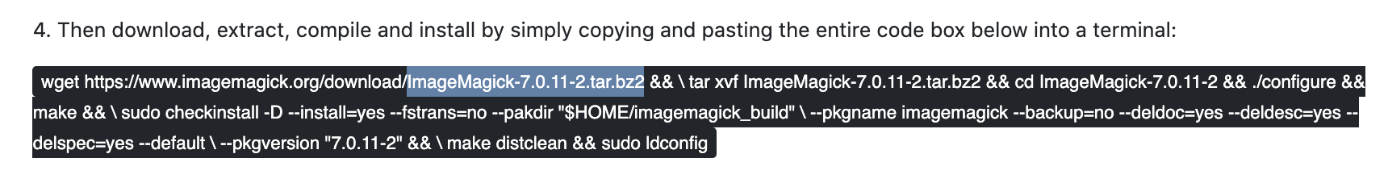
- To retrieve the most recent version, visit the website: https://www.imagemagick.org/download/
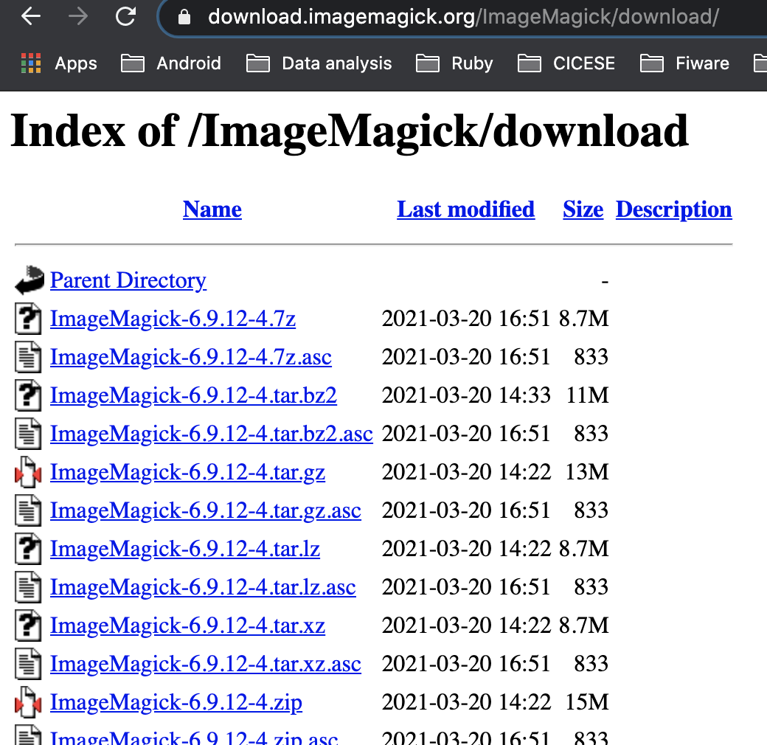
- Also, note that some computers will trigger an error when using the command in step 4. The expected error is quite clear: there is one blank space before tar and another before sudo. I encourage you to not ament this on the practical, as students should read and interpret prompt errors.

- The command to convert images from its regular version to black-and-white is -monochrome, although students could also justify using -negate. Both are ok. Example of how they process an image: convert <input> -monochrome <output>

- Students might run into the problem of having to deal with blank spaces in the filenames. They can use \ to space a blank space as a special character. For example: for FILE in *; do convert COVID-19\ \(*\).jpg -monochrome converted_COVID-19\ \(*\).jpg $FILE; done

- If students run into a cache error due to their limited computer resources, feel free to encourage them to create a sub-folder with ten images to process a mini-batch of images.

